Addio Ustaz Massimo Campanini
(3 November 1954 – 9 October 2020)

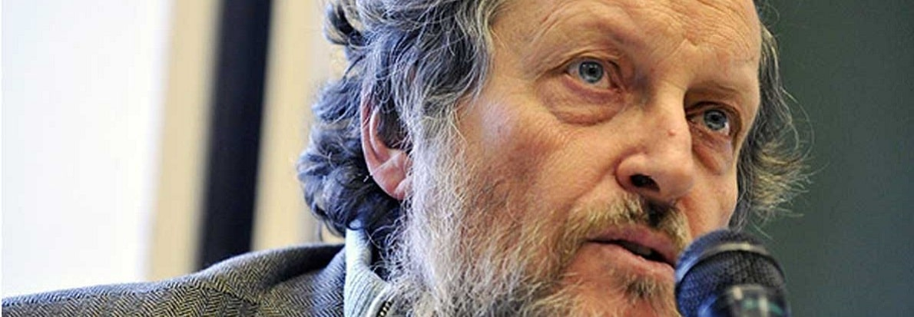

A professor of classical and contemporary Arabic and Islamic philosophy and of the Arabic Language at the universities of Urbino, Orientale di Napoli, Trento, Vita Salute San-Raffaele di Milano e IUSS di Pavia, Massimo Campanini, passed away in the morning hours of Friday, 9 October 2020 in his home in Milan following a heart attack and having struggled for several years with Parkinson’s disease.

He authored a number of books in Italian, as well as in English [An Introduction to Islamic Philosophy (Edinburgh UP, 2008), The Qur’an, Modern Muslim (Routledge, 2011), Philosophical Perspectives on Modern Qur’anic Exegesis (Equinox, 2016), Al-Ghazali and the Divine (Routledge, 2018), and, now posthumously, the Islamic political theology (Lexington, 2020 – to be published] (See: https://www.thriftbooks.com/a/massimo-campanini/633919/).

I was informed of his death on the same day by His Excellency Nicola Minasi, Ambassador of Italy to Bosnia and Herzegovina. His Excellency had expressed interest in supporting the project of bringing professor Campanini to Bosnia and Herzegovina to hold a series of public lectures entitled: Philosophy and the Qur’an: new hermeneutics for new times. The death of this prominent Italian pluralist thinker, professor of Islamic studies, an admirer of Sufism and a cosmopolitan – in a word, of the person who embodied, in a contemporary sense, the term hanīf /the one who maintains the pure monotheism of the patriarch Abraham (in accordance with his personal testimony in his work L’Islam: religione dell’ occidente/Islam, a Western Religion/ has shaken me, although I, as a hafiz, am well-acquainted with the maxim of the Qur’an that “We are closer to him than the jugular vein”. God’s will has been that we continue our almost two decades’ long friendship, which we started as co-editors with Oliver Leaman on Routledge’s edition of The Qur'an: an encyclopaedia (2006), in the afterlife, although we both were truly glad to be able to finally meet in person (I here cite his words from 5 September 2020: I hope too after so much time. Cari saluti.) Our last e-mail correspondence was on 30 September:
Good morning, buongiorno. I thank you all for your interest and appreciation and I will wait for a definite answer insha’Allah. Coi migliori saluti, best regards,
Instead of such a friendly meeting, I am now writing in his Burial Night an In memoriam to this true ustad, a professor of Arabic and Islamic philosophy and a professor of the Arabic Language, strongly hoping that we will continue our spiritual symposium in the Garden of Eden, God willing, since he, I am deeply convinced, deserves an eternal home in Heaven for a strong effort to renew the interest of the Italian people, as well as throughout the world, in a deeper understanding of the Arabic and Islamic culture. For, upon seen Alessandro Bausani’s translation of the Qur’an, professor Campanini developed the skill of intertwining contradictions, surpassing the usual bipolarities of mutually colliding/excluding paradigms, hence, after the Friday prayer, a Salat al-Janazah was performed for him, and he was buried today (Saturday, 10 October) according to the Christian tradition.

It would suffice to say the following: 32 books, 152 papers in 465 publications in 6 languages at 3328 libraries (http://worldcat.org/identities/lccn-n86120318/), while the Google Scholar provides 4610 results. It is certain that apart from philosophers and comparativists the representatives of the Qur’an studies (ˋulūm al-Qur'ān), for example, will have to pay attention to Massimo’s paving the way towards the philosophical studies of the Qur’an, since his entire opus is philosophical and theological in nature, i.e. it is a movement between the new and the old epistemological paradigms, especially keeping in mind the developed comparativist Mediterranean theology of co-existence and redefining of our space of the meeting, in which he was truly successful and inspiring.

Finally, keeping in mind his polyvalent propensities and an ostensibly refined complex identity, may God rest his soul and Allah rahmet eylesin!

Addio al professor Massimo Campanini, studioso di islam!

Mojmilo, 10 October 2020

Nevad KAHTERAN
Faculty of Philosophy, University of Sarajevo
(translated by Selma ĐULIMAN, Faculty of Philosophy, University of Sarajevo)

