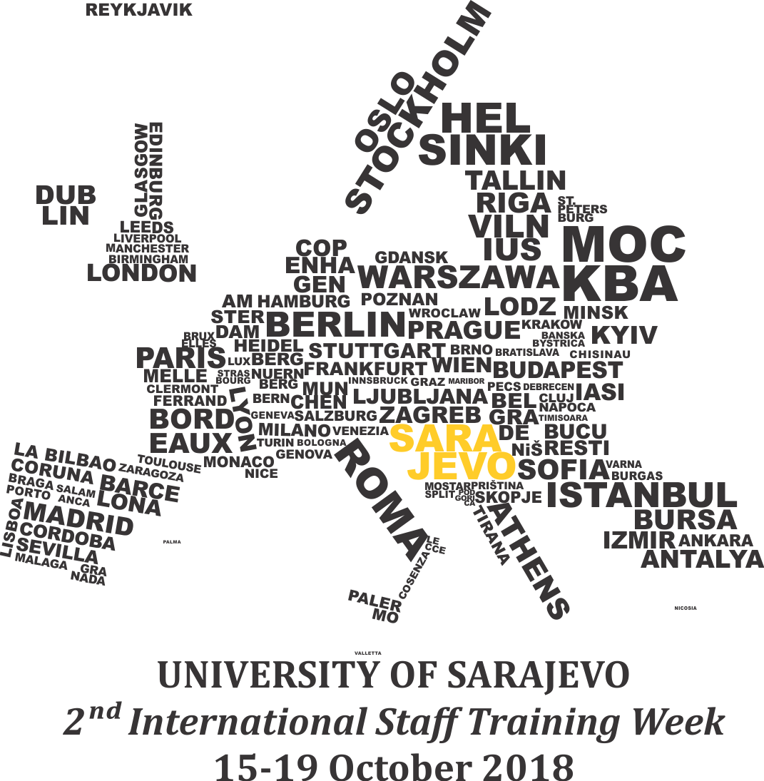
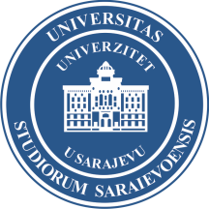
2nd International Staff training Week
University of Sarajevo
International Relations office

2ISTW Programme:
Monday, 15th October 2018
Location: Rectorate University of Sarajevo, Obala Kulina bana 7 (2nd floor)
Working language: English
Topic: Meet the City and University of Sarajevo
Hours: | Activities:
09:30 | Registration of participants
10:00 | Welcome reception:  - Opening speech  - Presentation of the 2ISTW Agenda
10:30 | This is UNSA  - presentation of the University of Sarajevo, its member institutions, programs and projects, study programmes  International Relations office
11:00 | Coffee break + group photo
11:30 | And you are…?  - a brief presentation of participants and their institutions, short Power point or Prezi presentation (max 5 slides) or video presentation (max 5 minutes)  Participants
13:00 | Lunch – check the map for recommended nearby places
14:30 | UNSA Centre for interdisciplinary studies  - presentation of Master programs
15:00 | Trip to Mostar  - presentation of the plan and timetable for the trip to Mostar and “Džemal Bijedić” University of Mostar  International Relations office
15:30 | Guided tour through Sarajevo  - guided tour of the city of Sarajevo with professional touristic guide (walking tour)

Tuesday, 16th October, 2018
Agenda for international partners who are going to Mostar
Location of the meeting: Train station Sarajevo
Time: 6:30
Hours | Activities
06:30 | Meeting of the group at the Train station Sarajevo
07:07 | Train departs to Mostar
09:30 | Expected arrival to Mostar and walk toward “Džemal Bijedić” University of Mostar (UNMO)
11:30 | International Day at UNMO session
14:30 | Lunch
16:00 | Guided tour through Mostar
17:04 | Train departs to Sarajevo

Tuesday, 16th October, 2018
Agenda for local UNSA participants -
Lokacija: Rektorat Univerziteta u Sarajevu, Obala Kulina bana 7
Radni jezik: Bosanski/hrvatski/srpski
Topic: Internacionalizacija Univerziteta u Sarajevu (Internationalisation of the University of Sarajevo)
Sati | Aktivnosti
09:30 | Registracija učesnika
10:00 | Uvodno obraćanje
10:15 | Predstavljanje izvještaja rada iz oblasti međunarodne saradnje Univerziteta u Sarajevu  prof. dr. Aleksandra Nikolić, prorektorica
10:30 | Predstavljanje izdanja Službe za međunarodnu saradnju:  - Zbirka uputa za mobilnost  - Vodič kroz implementaciju kreditne mobilnosti  - Study program exchange  - Instrukcije za prijavu na Erasmus+ poziv  Služba za međunarodnu saradnju
11:00 | Kafe pauza
11:30 | Predstavljanje rada (pod)organizacionih jedinica Univerziteta u Sarajevu iz oblasti međunarodne saradnje s posebnim fokusom na :  - iskustva implementacije međunarodne kreditne mobilnosti (distribucija informacija, raspisivanje konkursa, prijava i nominacija, susreti sa studentima, podrška prilikom odlaska na mobilnost, povratak i priznavanje rezultata)  Prodekani/koordinatori/kontakt osobe
12:30 | Iskustva studenata  - prezentiranje iskustava studenata na međunarodnoj mobilnosti
13:00 | Kako unaprijediti ponudu za inostrane studente i osoblje?  - otvorena sesija, zaključci
13:30 | Kraj sesije

Wednesday, 17th, October 2018
Location: Rectorate University of Sarajevo, Obala Kulina bana 7 (2nd floor)
Working language: English
Topic: Internationalisation@home
Hours | Activities
10:00 | Internationalisation@home  - presenting activities of the central International Relations office of the University of Sarajevo with the focus of incoming and outgoing students and staff  International Relations office
10:25 | Student support  - Erasmus Student Network
10:40 | Student and staff testimonials  - collection of stories, presentations, videos of local and incoming students and staff members
11:00 | Coffee break
11:30 | Student and staff testimonials  - collection of stories, presentations, videos of local and incoming students and staff members
12:00 | Successful application and project implementation  - Capacity building project: STINT
12:30 | Science and Research at the University of Sarajevo  - getting to know the host University's project options (presenting opportunities for cooperation through different funded programs and projects)  Office for Science and Research & Centre for support for projects
13:00 | Lunch – check the map for recommended nearby places
14:30 | “Know-how”  - presentation of work of the International Relations office at the:  1. University of Bologna  2. University of Porto
15:00 | 9th Scholarship fair – essential information  - providing needed administrative information about tomorrows event  International Relations office
15:15 | End of session

Thursday, 18 October 9th 2018 Scholarship fair
Location: Rectorate University of Sarajevo, Obala Kulina bana 7 (whole building)
Working language: Bosnian/Croatian/Serbian + English
Topic: Raising awareness of international mobility programs and option
Hours | Activities
09:00 | Arrival  - participants arrive and prepare their stand
10:00 | Opening ceremony of the 9th Scholarship fair  - welcome speech by:  prof. dr. Rifat Škrijelj, Rector of the University of Sarajevo  - Group photo
13:00 | Lunch – will be provided in the Rectorate
16:00 | End of the 9th Scholarship fair

Friday, 19th October 2018
Cultural activities

