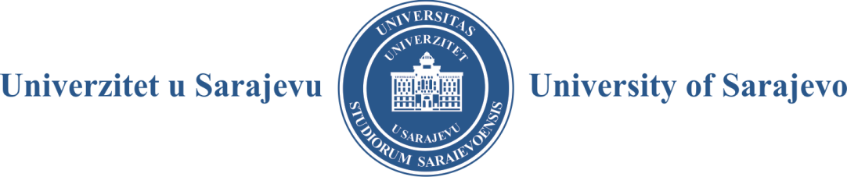

Pregled : Periodical for Social Issues

Call for Papers

Strategic Sustainability and Climate Resilience Planning and Policies in
Southeast Europe

The wealth of scientific data on climate change point to the inevitability of an increased number of natural disasters, leading to failed societies and the collapse of economies around the globe. The new realities of natural disasters, further accelerated by climate change and unsustainable growth, lead to uncharted territory for administrators, politicians, legislators, governments, and the general public and private sectors. While much of the debate and research focuses on developed countries with the highest GDP, there has been less focus on smaller, less industrialized regions and countries, leaving those populations exposed to climate vulnerabilities. There is limited research on strategic climate resilience and sustainability planning in countries from Southeast Europe, including Albania, Bosnia and Herzegovina, Bulgaria, Croatia, Cyprus, Greece, Kosovo, Montenegro, North Macedonia, Romania, Serbia, Slovenia, and Turkey.

The need to address these discrepancies in strategic resilience and sustainability planning is evident with each passing year at levels and stages of planning and all levels of government. Urban cities' populations are increasingly vulnerable to repeated heat waves—coastal areas to rising sea levels. More communities are exposed to natural disasters with frequent 500-year devastating rain events and recurrent unpredictability of weather patterns. The relatively limited analysis of strategic resilience and sustainability planning leaves academics, policymakers, and the public with little guidance on ensuring safety and reducing vulnerabilities of the population and businesses.

This symposium issue of Pregled aims to fill this informational gap by examining the missing research on political, governance, administrative, and other aspects of sustainability and climate resilience planning and its implications for society, economy, environment, and governance. Among other issues, the Symposium will provide a crucial discussion of questions such as: Does climate resilience and sustainability planning contribute to the overall benefit of the region and the country under review? Does this type of planning have measurable implications, and will it affect broader indices of good governance? Do countries or regions collaborate on climate resilience, sustainability planning, and related policies, and what are the ultimate outcomes of such plans and policies?

Univerzitet u Sarajevu – Obala Kulina bana 7/II, 71000 Sarajevo – Bosna i Hercegovina
Telefon: ++387(33)226-378; ++387(33)668-250 - fax: ++387(33)226-379
http://www.unsa.ba
email: javnost@unsa.ba

We welcome original manuscripts grounded in theoretical, qualitative, quantitative, or mixed-methods research. These may include surveys, ethnographies, and articles illuminating the unique planning and governing challenges administrators in the public sector face, given widespread climate change threats at all levels of government at national and local government levels. Manuscripts may also investigate the consequences of not addressing the issue, including the impact of climate change on the social and environmental dimensions of the communities and the entire nation. The article could address ongoing climate change denials, pseudoscience, and disinformation about climate change. Manuscripts may also examine the ethical problems that arise when the public is not informed on the issues of climate change threats and vulnerabilities. Manuscripts from a variety of fields will be considered, including but not limited to emergency management, political science, ethics of climate resilience, communication, management, nonprofits, governance, psychology, law, public policy, business, and public administration.

The special issue seeks manuscripts of 4,000 - 6,000 words, including references. Manuscripts must be submitted in English for consideration. If you would like to be considered for inclusion in this Symposium, please send an abstract of 500-600 words in English with complete contact information before December 15, 2022, to Dr. Haris Alibašić, Lead Symposium Editor at halibasic@uwf.edu and Dr. Senadin Lavić, the Editor-in-Chief of Pregled : Periodical for Social Issues at senadin.lavic@fpn.unsa.ba.

Authors will be notified by January 15, 2023, of the acceptance of their abstracts.

The deadline for submitting final manuscripts is May 15, 2023.

Univerzitet u Sarajevu – Obala Kulina bana 7/II, 71000 Sarajevo – Bosna i Hercegovina
Telefon: ++387(33)226-378; ++387(33)668-250 - fax: ++387(33)226-379
http://www.unsa.ba
email: javnost@unsa.ba

