Summer Japanese Language Program 2022
We are pleased to announce that the Summer Japanese Language Program will be held in September 2022. The Program offers the opportunity to learn Japanese language and culture with the aim to contribute to the building of friendship between the people of BiH, its neighboring countries and Japan. The Program is organized within the framework of a collaborative agreement between University of Sarajevo, BiH and Sophia University (上智大学), Tokyo, Japan, and supported by the Japan Embassy in BiH.
The Program is communication-oriented and provides participants with the opportunity to talk about their own culture and get to know Japanese culture. It offers each 3 on-site courses for 3 different levels from very beginners to more advanced, and 3 online classes for beginners. Courses will be offered on both weekdays and weekends with the same contents considering participants’ availability. The courses will be taught by three graduate students specialized in Japanese language pedagogy. Please see details of each course and teacher’s introduction below.

- Course Schedule for FACE-TO-FACE classes (showed time zone= in BiH)
From 5th September To 23rd September 2022 (maximum 8 classes each)
Every course will be offered online and the maximum number of participants for each class is 10 people.
Whoever can participate on a fist come, first served basis.

▶Japanese Beginner： A. Mondays & Wednesdays 17:00 – 18:30
B. Mondays & Wednesdays 18:45 - 20:15
C. Saturdays 15:00 - 18:15
▶Japanese Intermediate： D. Mondays & Wednesdays 17:00 – 18:30
E. Mondays & Wednesdays 18:45 - 20:15
F. Saturdays 15:00 - 18:15
▶Japanese Upper-intermediate/ Advanced : G. Mondays & Wednesdays 17:00 – 18:30
H. Mondays & Wednesdays 18:45 - 20:15
I. Saturdays 15:00 - 18:15
※ The course contents on Mondays & Wednesday and on Saturdays are the same!!
Please choose weekdays course or weekends course depending on your preference and availability.
Time Table

 | Monday | Tuesday | Wednesday | Thursday | Friday | Saturday | Sunday
15:00  ~  18:15 |  |  |  |  |  | -Beginner [C]  -Intermediate [F]  -Upper-intermediate /advanced [I]
17:00  ~  18:30 | - Beginner [A]  -Intermediate [D]  -Upper-intermediate /advanced [G] |  | - Beginner [A]  -Intermediate [D]  -Upper-intermediate /advanced [G]
18:45  ~  20:15 | - Beginner [B]  -Intermediate [E]  -Upper-intermediate /advanced [H] |  | - Beginner [B]  -Intermediate [E]  -Upper-intermediate /advanced [H]

- Course Schedule for ONLINE classes (showed time zone= in BiH)

From 5th September To 25th September 2022
Every course will be offered online and the maximum number of participants for each class is 10 people. Whoever can participate on a fist come, first served basis.

▶Japanese Beginner： a. Tuesdays and Fridays: 17:00-18:00
▶Japanese Intermediate： b. Saturdays 17:00 – 19:00
▶Japanese Upper-intermediate/ Advanced : c. Sundays 17:00 – 19:00

※ The lecture contents are the same across all the class schedule offered. Please choose a course depending on your preference and availability.
※ We might ask you to move to different sections/time-frame depending on the numbers of applicants.

Time Table

 | MON | Tuesday | WED | THU | Friday | Saturday | Sunday
17:00  ~  18:30 |  | -Beginner  (Classes for other level can be arranged depending on the number of applicants) |  |  | -Beginner  (Classes for other level can be a-rranged depend-ing on the number of applicants) | -Intermediate  (Classes for other level can be arranged depend-ing on the number of applicants) | -Advanced  (Classes for other level can be arranged depend-ing on the number of applicants)
18:30
~
20:00

- Course Description
Japanese Beginner | This course is designed for students who have never studied the Japanese language before. In this course, you will start off learning some basic phrases that you can use to have a daily conversation in Japanese and Japanese letters such as あいうアイウ. In the beginning, you might find learning Japanese difficult, but we will try to incorporate many interesting activities so that you can study Japanese having fun and be motivated to study Japanese more.  In this course, you’ll also learn Japanese cultures in addition to the Japanese language. You’ll get to know the Japanese lifestyles, Japanese cities, foods, the Japanese ways of thinking and so on. As for the cultural part, we can deal flexibly according to what you’re interested in and will arrange what we do/learn in classes.  Students with a little experience with learning Japanese (those who with less than six-month learning span or who took Japanese 1 online class last year) are also welcome.
Japanese Intermediate | This course is designed for students whose Japanese level is in upper-beginner to intermediate. The aim of this course is to brush up speaking and listening skills. Students will learn Japanese phrases used in ordinary situations through conversational practices. This course is aimed at students in the Level 1 to 2 of regular Japanese course or who have learnt Japanese for more than a year and know basic Japanese grammar. The knowledge of the Japanese writing system (Hiragana) is required. Other writing form (カタカナ, & 漢字) are not required, but we are likely to touch on daily-base uses of them such as for names and places.
Japanese  Upper-intermediate/ Advanced | This course is designed for students who have basic knowledge of Japanese and can have a conversation in some daily situations. The topic of the conversations will range from practical daily usage to less-familiar, rather academic content. The topic for each session will be determined considering the preference, proficiency, needs, and interest of the applicants. In this course, we will deal with various topics through many activities such as discussion, presentation and so on. This course is designed for students who are in the Level 3 or 4of regular Japanese course whose level is upper – intermediate to advanced.  More advanced learners are welcomed too!!

◆ Languages of Instruction
Japanese and English
※The classes will be conducted mostly in Japanese. English will be used only supplementally.
- Registration
Please fill out an application form from URL below.
The maximum number of participants for each class is 10 people and whoever can participate on a fist come, first served basis!!

Applications must be submitted no later than 15th of August. You’ll receive a confirmation mail at a later date.
For FACE-TO-FACE classes: https://padlet.com/mtclub2015/724okfkn048o9zyg/wish/2243409334
For ONLINE classes: https://padlet.com/mtclub2015/724okfkn048o9zyg/wish/2243408860
- Course fee
To participate in the classes, you need to pay 25KM.
The course fee is the same for both on-site and online classes.
Once you enroll to the classes you are expected to attend all the scheduled lectures and even though you decided to stop showing up to the classes, there will be no refund. If for any reason you will miss a class, please notify the instructors in advance.
※Note that if you skip several classes without notifying us, we might reject your application in future programs.

Summer Japanski Jezik Program 2022
We are the teachers!!
This September, online Japanese courses will be offered
by 3 teachers from Sophia university.
We all are looking forward to having a wonderful time with you!

齊藤有香 (Saito Yuka)
はじめまして。伊藤雅子です。趣味は料理とヨガです。仕事で色々な所へ行きましたが、残念ながらサラエボを訪れたことはありません。ぜひ皆さんと一緒に楽しい日本語の時間を過ごしたいです。皆さんとお会いできるのを楽しみにしています。
Hi, I'm Masako Ito．My hobbies are cooking and yoga.I've been to many places in the world for work, but unfortunately I’ve never visited Sarajevo. I would love to spend a pleasant time in Japanese with you. I am looking forward to meeting you all.

伊藤雅子 (Ito Masako)
こんにちは！わたしは石原翔也です。趣味は映画とスポーツを観ることで、それについて皆さんとお話ししたいです。世界の料理や文化にも興味があるので、みなさんから色々なお話を聞くのが楽しみです！お会いできるのを楽しみにしています
Hello! I’m Shoya Ishihara. I like watching movies and sports, and I’d be happy if I can get to talk about them with you. I am also really interested in foreign foods and culture, and I am looking forward to seeing you and learn about your culture from you! I am very excited to see you all!
May the Force be with you.

石原翔也 (Ishihara Shoya)
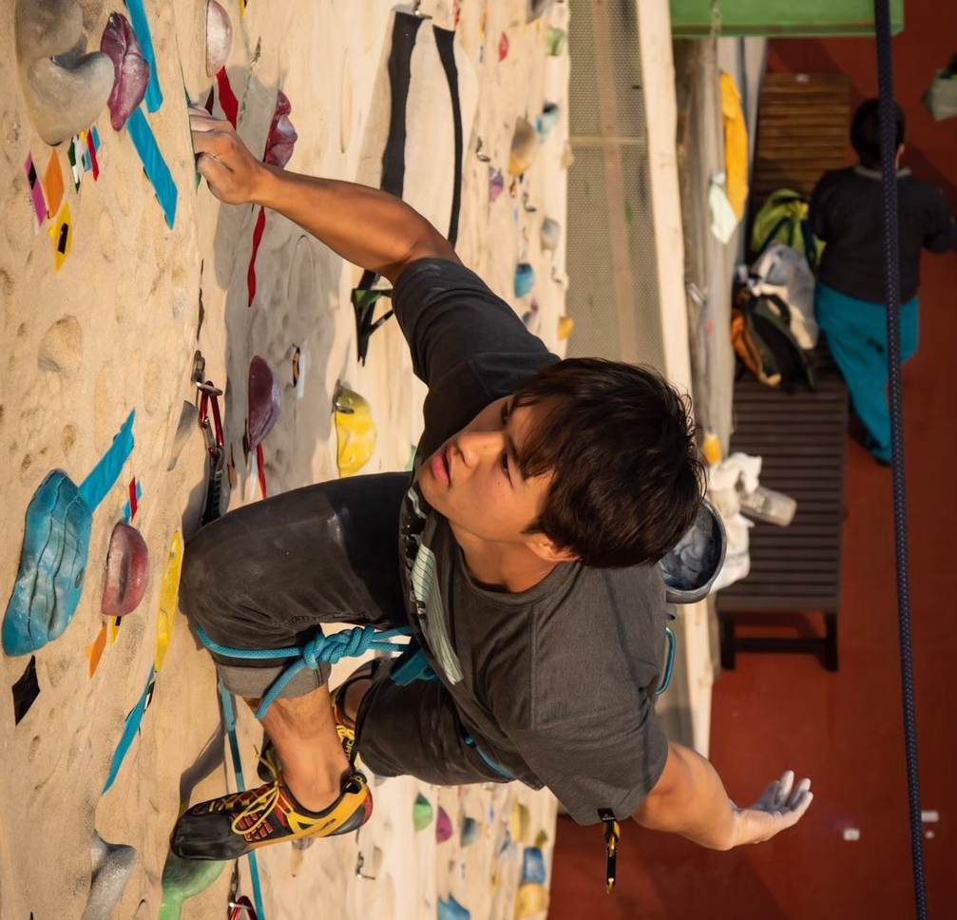
畠山政大 (Hatakeyama Masahiro)
こんにちは。わたしは畠山政大です。登山が好きです。ディナール山脈にあるトレスカヴィツァ山とマグリッチ山に行きたいと思っています。見ての通り、セルビア語を勉強しているので教えてください。その代わり、日本のことを教えます←（冗談です）。さておき、このプログラムを通じて日本語を楽しんでいただけると嬉しいです！
Dobar dan ! Ja sam Masahiro Hatakeyama. Ja volim da popem se na planinu. I really want to climb Dinarske planine, especially Mt.Treskavica and Mt. Maglić. As you can see, I’m studying bosanski jezik so please tell me about your language. Instead, I’m going to tell you something about Japan←（just kidding）.Anyway, it would be nice if you would enjoy Japanese through this program !

あべふみ です。私は動物が大好きで、猫と犬を飼っています。夢は、大きな家に住んで沢山の動物に囲まれて暮らすことです。みなさんとお会いできるのを楽しみにしています。
Hi, I’m Fumi Abe. I love animals and I have a cat and a dog. I dream one day I could live in a huge house living with a lot of animals. I am looking forward to seeing you.
はじめまして、近藤穂香です。皆さんと日本語で話せるのを楽しみにしています。散歩と読書が大好きです。いつかサラエボの町も散歩したいです。おすすめの本があったら、ぜひ教えてくださいね。
Hello, I’m Honoka Kondo. I’m really looking forward to talking with you all in Japanese. Strolling and reading books make me alive. I’d love to take a walk around in Sarajevo someday. If you have a favorite book, let me know one :)

こんにちは、私は伊藤こころです。おいしい食べ物を食べるのが大好きです。おすすめのボスニア料理があればぜひ知りたいです！今回はサラエボにいけませんが、みなさんとお会いできるのを楽しみにしています。
Hi, I'm Kokoro Ito. I like eating delicious food. I'd love it if you could tell me the Bosnian Foods that you recommend. This time, I'll not be able to go to Sarajevo, but I'm really looking forward to talking with you.
